Chapter 5 – System Modeling
1. System modeling
- System modeling is the process of developing abstract models of a system, with each model presenting a different view or perspective of that system.
- System modeling has now come to mean representing a system using some kind of graphical notation, which is now almost always based on notations in the Unified Modeling Language (UML).
- System modelling helps the analyst to understand the functionality of the system and models are used to communicate with customers
2. Existing and planned system models
- Models of the existing system are used during requirements engineering. They help clarify what the existing system does and can be used as a basis for discussing its strengths and weaknesses. These then lead to requirements for the new system.
- Models of the new system are used during requirements engineering to help explain the proposed requirements to other system stakeholders. Engineers use these models to discuss design proposals and to document the system for implementation.
- In a model-driven engineering process, it is possible to generate a complete or partial system implementation from the system model
3. System perspectives
- An external perspective, where you model the context or environment of the system.
- An interaction perspective, where you model the interactions between a system and its environment, or between the components of a system.
- A structural perspective, where you model the organization of a system or the structure of the data that is processed by the system.
- A behavioral perspective, where you model the dynamic behavior of the system and how it responds to events
4. UML diagram types
- Activity diagrams, which show the activities involved in a process or in data processing .
- Use case diagrams, which show the interactions between a system and its environment.
- Sequence diagrams, which show interactions between actors and the system and between system components.
- Class diagrams, which show the object classes in the system and the associations between these classes.
- State diagrams, which show how the system reacts to internal and external events
5. Use of graphical models
- As a means of facilitating discussion about an existing or proposed system
+ Incomplete and incorrect models are OK as their role is to support discussion.
- As a way of documenting an existing system
+ Models should be an accurate representation of the system but need not be complete.
- As a detailed system description that can be used to generate a system implementation
+ Models have to be both correct and complete
6. Context models
- Context models are used to illustrate the operational context of a system - they show what lies outside the system boundaries.
- Social and organisational concerns may affect the decision on where to position system boundaries.
- Architectural models show the system and its relationship with other systems
7. System boundaries
- System boundaries are established to define what is inside and what is outside the system.
+ They show other systems that are used or depend on the system being developed.
- The position of the system boundary has a profound effect on the system requirements.
- Defining a system boundary is a political judgment
+ There may be pressures to develop system boundaries that increase / decrease the influence or workload of different parts of an organization
8. Process perspective
- Context models simply show the other systems in the environment, not how the system being developed is used in that environment.
- Process models reveal how the system being developed is used in broader business processes.
- UML activity diagrams may be used to define business process models
9. Interaction models
- Modeling user interaction is important as it helps to identify user requirements.
- Modeling system-to-system interaction highlights the communication problems that may arise.
- Modeling component interaction helps us understand if a proposed system structure is likely to deliver the required system performance and dependability.
- Use case diagrams and sequence diagrams may be used for interaction modeling.
10. Use case modeling
- Use cases were developed originally to support requirements elicitation and now incorporated into the UML
- Each use case represents a discrete task that involves external interaction with a system.
- Actors in a use case may be people or other systems.
- Represented diagrammatically to provide an overview of the use case and in a more detailed textual form
11. Sequence diagrams
- Sequence diagrams are part of the UML and are used to model the interactions between the actors and the objects within a system.
- A sequence diagram shows the sequence of interactions that take place during a particular use case or use case instance.
- The objects and actors involved are listed along the top of the diagram, with a dotted line drawn vertically from these.
- Interactions between objects are indicated by annotated arrows.
12. Structural models
- Structural models of software display the organization of a system in terms of the components that make up that system and their relationships.
- Structural models may be static models, which show the structure of the system design, or dynamic models, which show the organization of the system when it is executing.
- You create structural models of a system when you are discussing and designing the system architecture

13. Class diagrams
- Class diagrams are used when developing an objectoriented system model to show the classes in a system
and the associations between these classes.
- An object class can be thought of as a general definition of one kind of system object.
- An association is a link between classes that indicates that there is some relationship between these classes.
- When you are developing models during the early stages of the software engineering process, objects represent something in the real world, such as a patient, a prescription, doctor, etc

14. Generalization
- Generalization is an everyday technique that we use to manage complexity.
- Rather than learn the detailed characteristics of every entity that we experience, we place these entities in more general classes (animals, cars, houses, etc.) and learn the characteristics of these classes.
- This allows us to infer that different members of these classes have some common characteristics e.g. squirrels and rats are rodents
- In modeling systems, it is often useful to examine the classes in a system to see if there is scope for generalization. If changes are proposed, then you do not have to look at all classes in the system to see if they are affected by the change.
- In object-oriented languages, such as Java, generalization is implemented using the class inheritance mechanisms built into the language.
- In a generalization, the attributes and operations associated with higher-level classes are also associated with the lower-level classes.
- The lower-level classes are subclasses inherit the attributes and operations from their superclasses. These lower-level classes then add more specific attributes and operations
15. Object class aggregation models
- An aggregation model shows how classes that are collections are composed of other classes.
- Aggregation models are similar to the part-of relationship in semantic data models
16. Behavioral models
- Behavioral models are models of the dynamic behavior of a system as it is executing. They show what happens or what is supposed to happen when a system responds to a stimulus from its environment.
- You can think of these stimuli as being of two types:
+ Data Some data arrives that has to be processed by the system.
+ Events Some event happens that triggers system processing. Events may have associated data, although this is not always the case
17. Data-driven modeling
- Many business systems are data-processing systems that are primarily driven by data. They are controlled by the data input to the system, with relatively little external event processing.
- Data-driven models show the sequence of actions involved in processing input data and generating an associated output.
- They are particularly useful during the analysis of requirements as they can be used to show end-to-end processing in a system
18. Event-driven modeling
- Real-time systems are often event-driven, with minimal data processing. For example, a landline phone switching system responds to events such as ‘receiver off hook’ by generating a dial tone.
- Event-driven modeling shows how a system responds to external and internal events.
- It is based on the assumption that a system has a finite number of states and that events (stimuli) may cause a transition from one state to another
19. State machine models
- These model the behaviour of the system in response to external and internal events.
- They show the system’s responses to stimuli so are often used for modelling real-time systems.
- State machine models show system states as nodes and events as arcs between these nodes. When an event occurs, the system moves from one state to another.
- Statecharts are an integral part of the UML and are used to represent state machine models
20. Model-driven engineering
- Model-driven engineering (MDE) is an approach to software development where models rather than programs are the principal outputs of the development process.
- The programs that execute on a hardware/software platform are then generated automatically from the models.
- Proponents of MDE argue that this raises the level of abstraction in software engineering so that engineers no longer have to be concerned with programming language details or the specifics of execution platforms
21. Usage of model-driven engineering
- Model-driven engineering is still at an early stage ofdevelopment, and it is unclear whether or not it will have a significant effect on software engineering practice.
- Pros
+ Allows systems to be considered at higher levels of abstraction
+ Generating code automatically means that it is cheaper to adapt systems to new platforms.
- Cons
+ Models for abstraction and not necessarily right for implementation.
+ Savings from generating code may be outweighed by the costs of developing translators for new platforms
22. Model driven architecture
- Model-driven architecture (MDA) was the precursor of more general model-driven engineering
- MDA is a model-focused approach to software design and implementation that uses a subset of UML models to describe a system.
- Models at different levels of abstraction are created. From a high-level, platform independent model, it is possible, in principle, to generate a working program without manual intervention.
23. Types of model
- A computation independent model (CIM): These model the important domain abstractions used in a system. CIMs are sometimes called domain models.
- A platform independent model (PIM): These model the operation of the system without reference to its implementation. The PIM is usually described using UML models that show the static system structure and how it responds to external and internal events.
- Platform specific models (PSM): These are transformations of the platform-independent model with a separate PSM for each application platform. In principle, there may be layers of PSM, with each layer adding some platform-specific detail
24. Agile methods and MDA
- The developers of MDA claim that it is intended to support an iterative approach to development and so can be used within agile methods.
- The notion of extensive up-front modeling contradicts the fundamental ideas in the agile manifesto and I suspect that few agile developers feel comfortable with modeldriven engineering.
- If transformations can be completely automated and a complete program generated from a PIM, then, in principle, MDA could be used in an agile development process as no separate coding would be required.
25. Adoption of MDA
- A range of factors has limited the adoption of MDE/MDA - Specialized tool support is required to convert models from one level to another
- There is limited tool availability and organizations may require tool adaptation and customisation to their environment
- For the long-lifetime systems developed using MDA, companies are reluctant to develop their own tools or rely on small companies that may go out of business
- Models are a good way of facilitating discussions about a software design. Howeverthe abstractions that are useful for discussions may not be the right abstractions for implementation.
- For most complex systems, implementation is not the major problem – requirements engineering, security and dependability, integration with legacy systems and testing are all more significant
- The arguments for platform-independence are only valid for large, long-lifetime systems. For software products and information systems, the savings from the use of MDA are likely to be outweighed by the costs of its introduction and tooling.
- The widespread adoption of agile methods over the same period that MDA was evolving has diverted attention away from model-driven approaches

26. Key points
- A model is an abstract view of a system that ignores system details. Complementary system models can be developed to show the system’s context, interactions, structure and behavior.
- Context models show how a system that is being modeled is positioned in an environment with other systems and processes.
- Use case diagrams and sequence diagrams are used to describe the interactions between users and systems in the system being designed. Use cases describe interactions between a system and external actors; sequence diagrams add more information to these by showing interactions between system objects.
- Structural models show the organization and architecture of a system. Class diagrams are used to define the static structure of classes in a system and their associations
- Behavioral models are used to describe the dynamic behavior of an executing system. This behavior can be modeled from the perspective of the data processed by the system, or by the events that stimulate responses from a system.
- Activity diagrams may be used to model the processing of data, where each activity represents one process step.
- State diagrams are used to model a system’s behavior in response to internal or external events.
- Model-driven engineering is an approach to software development in which a system is represented as a set of models that can be automatically transformed to executable code

CHAP 6 – ARCHITECTURE DESIGN
Architectural design
- Architectural design is concerned with understanding how a software system should be organized and designing the overall structure of that system.
- Architectural design is the critical link between design and requirements engineering, as it identifies the main structural components in a system and the relationships between them.
- The output of the architectural design process is an architectural model that describes how the system is organized as a set of communicating components.

Agility and architecture
- It is generally accepted that an early stage of agile processes is to design an overall systems architecture.
- Refactoring the system architecture is usually expensive because it affects so many components in the system

The architecture of a packing robot control system

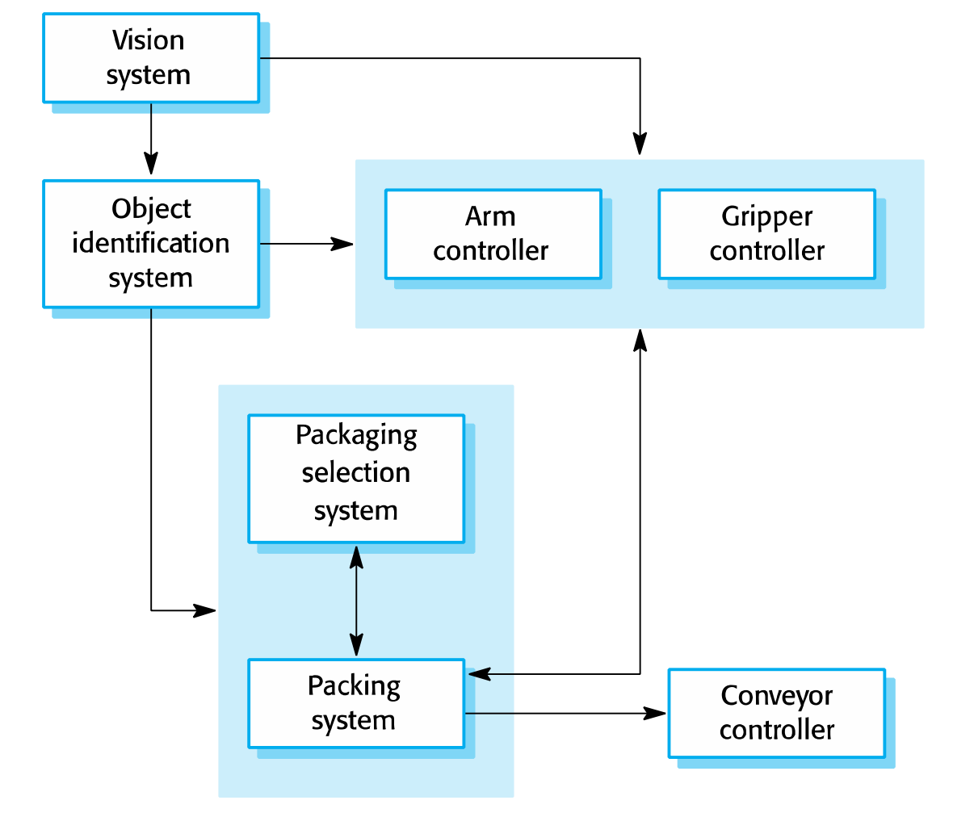
Architectural abstraction
- Architecture in the small is concerned with the architecture of individual programs. At this level, we are concerned with the way that an individual program is decomposed into components.
- Architecture in the large is concerned with the architecture of complex enterprise systems that include other systems, programs, and program components.
- These enterprise systems are distributed over different computers, which may be owned and managed by different companies.
Advantages of explicit architecture
- Stakeholder communication
+Architecture may be used as a focus of discussion by system
+stakeholders.
- System analysis
+Means that analysis of whether the system can meet its nonfunctional requirements is possible.
- Large-scale reuse
+The architecture may be reusable across a range of systems
+Product-line architectures may be developed.
Architectural representations
- Simple, informal block diagrams showing entities and relationships are the most frequently used method for documenting software architectures.
- But these have been criticized because they lack semantics, do not show the types of relationships between entities nor the visible properties of entities in the architecture.
- Depends on the use of architectural models. The requirements for model semantics depends on how the models are used.
Box and line diagrams
- Very abstract - they do not show the nature of component relationships nor the externally visible properties of the sub-systems.
- However, useful for communication with stakeholders and for project planning.
Use of architectural models
- As a way of facilitating discussion about the system design
+ A high-level architectural view of a system is useful for communication with system stakeholders and project planning because it is not cluttered with detail. Stakeholders can relate to it and understand an abstract view of the system. They can then discuss the system as a whole without being confused by detail.
- As a way of documenting an architecture that has been designed
+ The aim here is to produce a complete system model that shows the different components in a system, their interfaces and their connections.

Architecture reuse
- Systems in the same domain often have similar architectures that reflect domain concepts.
- Application product lines are built around a core architecture with variants that satisfy customer requirements.
- The architecture of a system may be designed around one of more architectural patterns or “styles”.
+ These capture the essence of an architecture and can be instantiated in different ways.
Architecture and system characteristics
- Performance: Localize critical operations and minimize communications. Use large rather than fine-grain components.
- Security: Use a layered architecture with critical assets in the inner layers.
- Safety: Localize safety-critical features in a small number of subsystems.
- Availability: Include redundant components and mechanisms for fault tolerance.
- Maintainability: Use fine-grain, replaceable components
Architectural views
- What views or perspectives are useful when designing and documenting a system’s architecture?
- What notations should be used for describing architectural models?
- Each architectural model only shows one view or perspective of the system.
+ It might show how a system is decomposed into modules, how the run-time processes interact or the different ways in which system components are distributed across a network. For both design and documentation, you usually need to present multiple views of the software architecture

4 + 1 view model of software architecture
- A logical view, which shows the key abstractions in the system as objects or object classes.
- A process view, which shows how, at run-time, the system is composed of interacting processes.
- A development view, which shows how the software is decomposed for development.
- A physical view, which shows the system hardware and how software components are distributed across the processors in the system.
- Related using use cases or scenarios (+1)
Representing architectural views
- Some people argue that the Unified Modeling Language (UML) is an appropriate notation for describing and documenting system architectures
- I disagree with this as I do not think that the UML includes abstractions appropriate for high-level system description.
- Architectural description languages (ADLs) have been developed but are not widely used
Architectural patterns
- Patterns are a means of representing, sharing and reusing knowledge.
- An architectural pattern is a stylized description of good design practice, which has been tried and tested in different environments.
- Patterns should include information about when they are and when they are not useful.
- Patterns may be represented using tabular and graphical descriptions.
The Model-View-Controller (MVC) pattern
- Description: Separates presentation and interaction from the system data. The system is structured into three logical components that interact with each other. The Model component manages the system data and associated operations on that data. The View component defines and manages how the data is presented to the user. The Controller component manages user interaction (e.g., key presses, mouse clicks, etc.) and passes these interactions to the View and the Model. See Figure 6.3
- Example: Figure 6.4 shows the architecture of a web-based application system organized using the MVC pattern.
- When used: Used when there are multiple ways to view and interact with data. Also used when the future requirements for interaction and presentation of data are unknown.
- Advantage: Allows the data to change independently of its representation and vice versa. Supports presentation of the same data in different ways with changes made in one representation shown in all of them.
- Disadvantage: Can involve additional code and code complexity when the data model and interactions are simple.

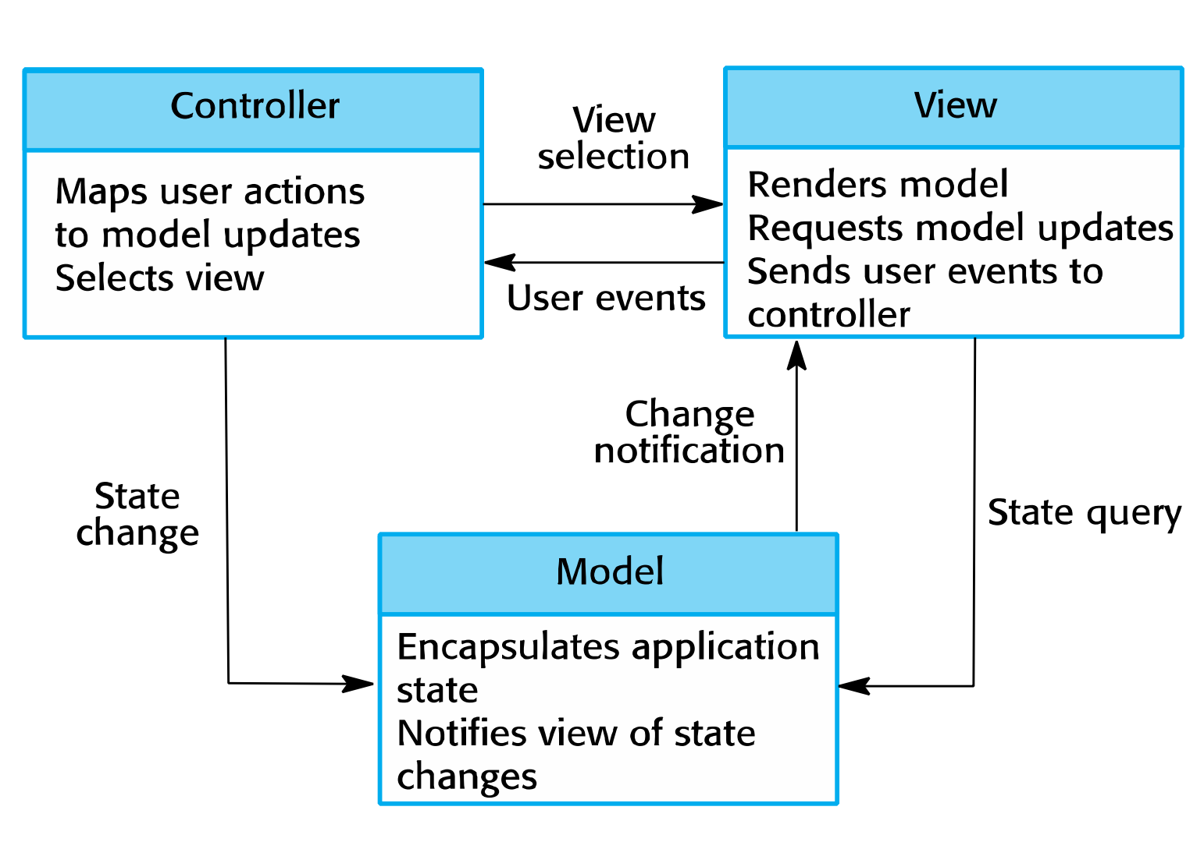

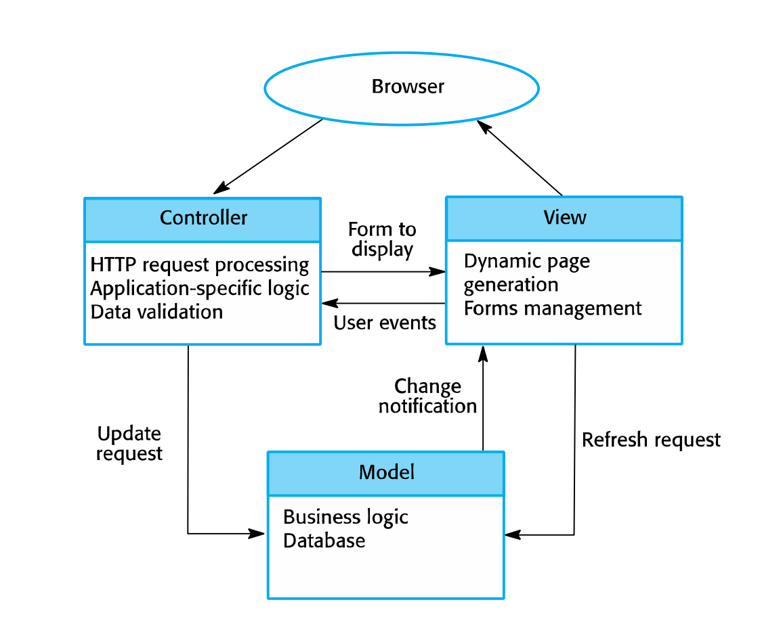

Layered architecture
- Used to model the interfacing of sub-systems.
- Organizes the system into a set of layers (or abstract machines) each of which provide a set of services.
- Supports the incremental development of sub-systems in different layers. When a layer interface changes, only the adjacent layer is affected.
- However, often artificial to structure systems in this way.
The Layered architecture patterns
- Description: Organizes the system into layers with related functionality associated with each layer. A layer provides services to the layer above it so the lowest-level layers represent core services that are likely to be used throughout the system. See Figure 6.6
- Example: A layered model of a system for sharing copyright document shield in different libraries, as shown in Figure 6.7.
- When used: Used when building new facilities on top of existing systems; when the development is spread across several teams with each team responsibility for a layer of functionality; when there is a requirement for multi-level security.
- Advantages: Allows replacement of entire layers so long as the interface is maintained. Redundant facilities (e.g., authentication) can be provided in each layer to increase the dependability of the system
- Disadvantages: In practice, providing a clean separation between layers is often difficult and a high-level layer may have to interact directly with lower-level layers rather than through the layer immediately below it. Performance can be a problem because of multiple levels of interpretation of a service request as it is processed at each layer.

A generic layered architecture

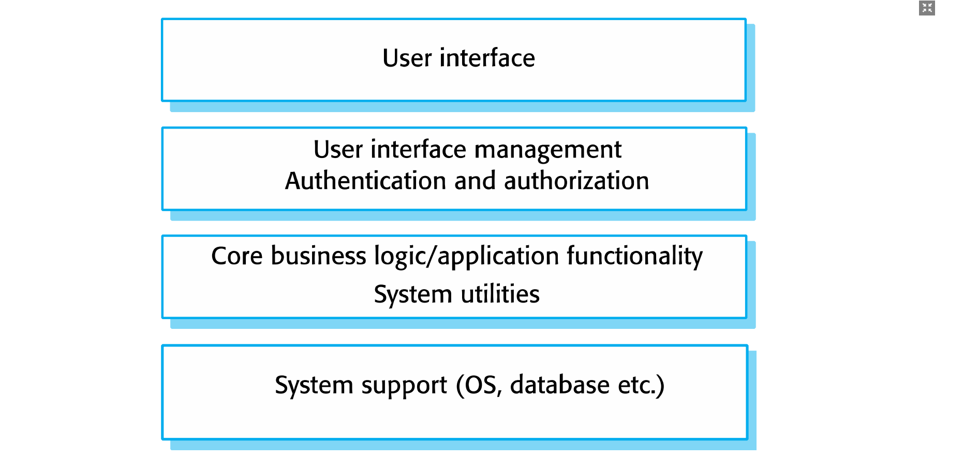
Repository architecture
- Sub-systems must exchange data. This may be done in two ways:
+ Shared data is held in a central database or repository and may be accessed by all sub-systems;
+ Each sub-system maintains its own database and passes data explicitly to other sub-systems.
- When large amounts of data are to be shared, the repository model of sharing is most commonly used a this is an efficient data sharing mechanism.
The Repository pattern
- Description: All data in a system is managed in a central repository that is accessible to all system components. Components do not interact directly, only through the repository
- Example: Figure 6.9 is an example of an IDE where the components use a repository of system design information. Each software tool generates information which is then available for use by other tools.
- When used: You should use this pattern when you have a system in which large volumes of information are generated that has to be stored for a long time. You may also use it in data-driven systems where the inclusion of data in the repository triggers an action or tool.
- Advantage: Components can be independent—they do not need to know of the existence of other components. Changes made by one component can be propagated to all components. All data can be managed consistently (e.g., backups done at the same time) as it is all in one place.
- Disadvantage: The repository is a single point of failure so problems in the repository affect the whole system. May be inefficiencies inorganizing all communication through the repository. Distributing the repository across several computers may be difficult.

A repository architecture for an IDE

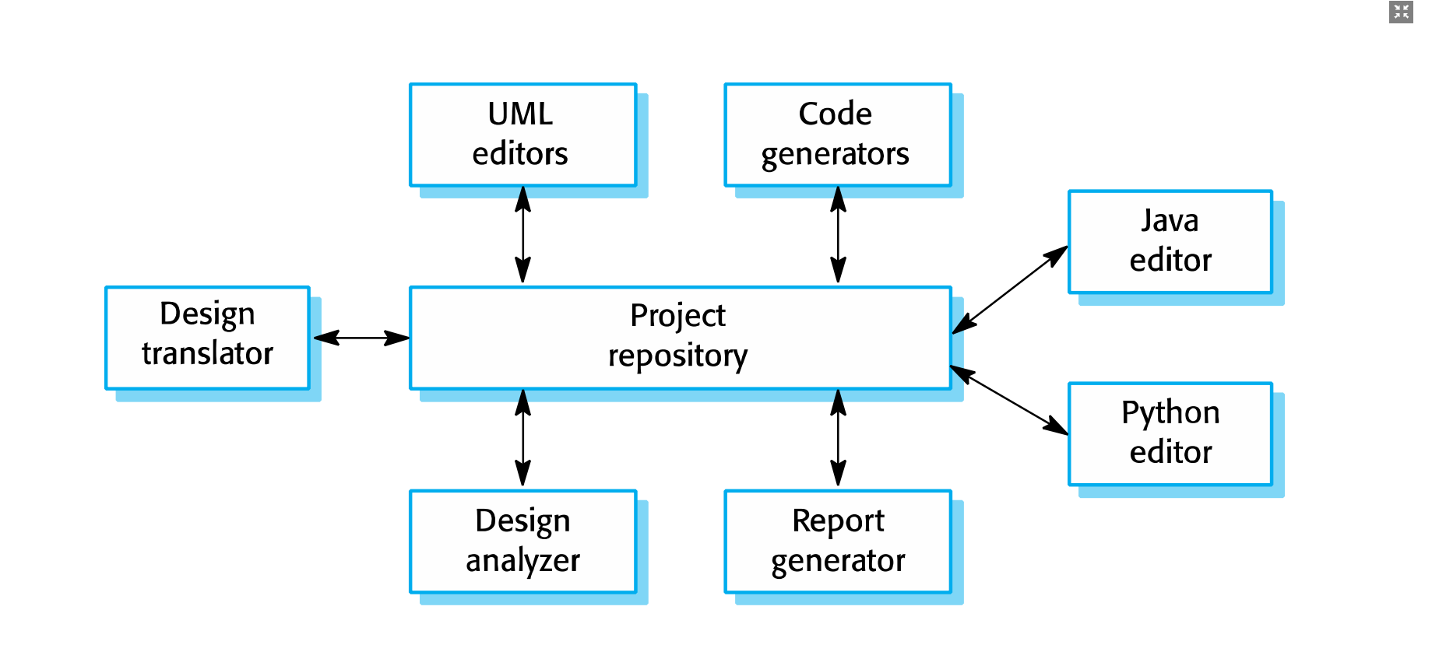
Client-server architecture
- Distributed system model which shows how data and processing is distributed across a range of components.
+ Can be implemented on a single computer.
- Set of stand-alone servers which provide specific services such as printing, data management, etc.
- Set of clients which call on these services.
- Network which allows clients to access servers.

- Description: In a client–server architecture, the functionality of the system is organized into services, with each service delivered from a separate server. Clients are users of these services and access servers to make use of them.
- Example: Figure 6.11 is an example of a film and video/DVD library organized as a client–server system.
- When used: Used when data in a shared database has to be accessed from a range of locations. Because servers can be replicated, may also be used when the load on a system is variable.
- Advantage: The principal advantage of this model is that servers can be distributed across a network. General functionality (e.g., a printing service) can be available to all clients and does not need to be implemented by all services.
- Disadvantage: Each service is a single point of failure so susceptible to denial of service attacks or server failure. Performance may be unpredictable because it depends on the network as well as the system. May be management problems if servers are owned by different organizations.

A client–server architecture for a film library

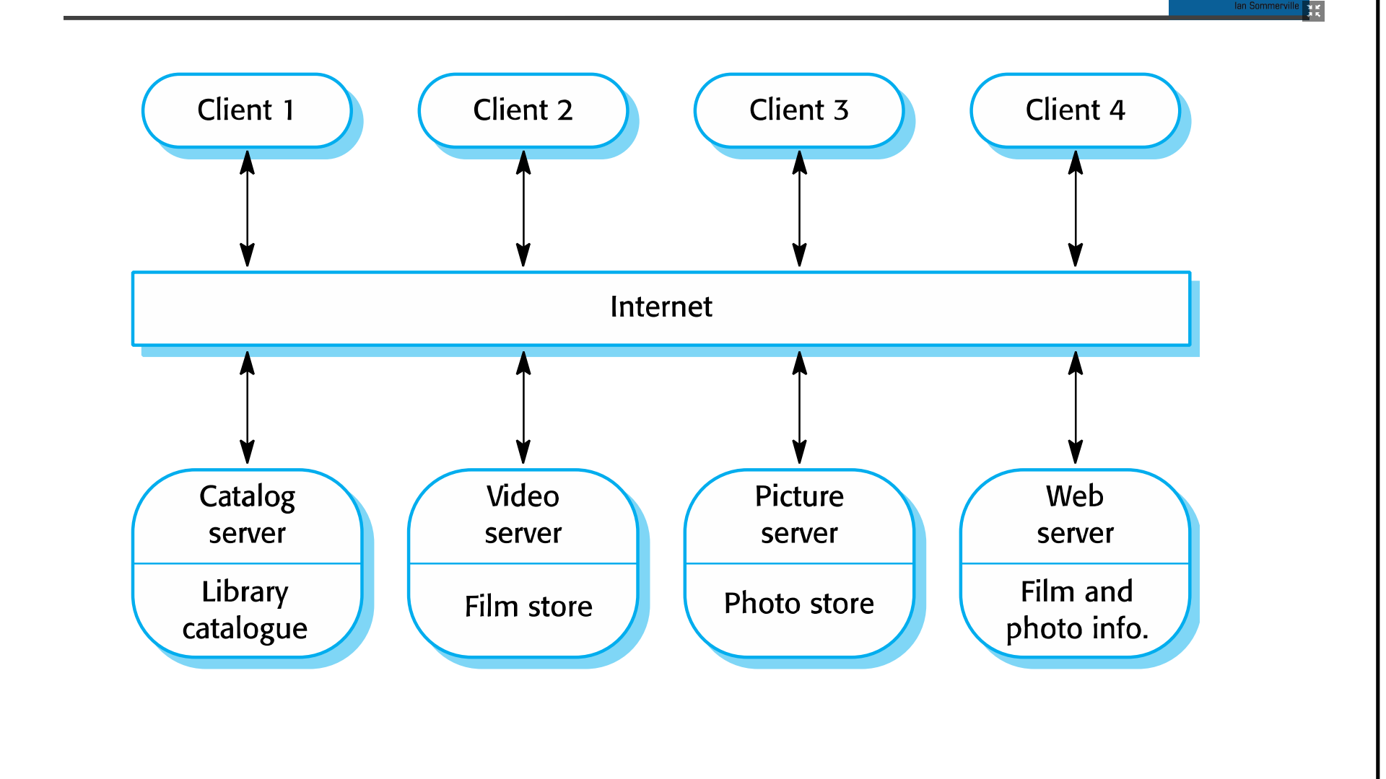
Pipe and filter architecture
- Functional transformations process their inputs to produce outputs.
- May be referred to as a pipe and filter model (as in UNIX shell).
- Variants of this approach are very common. When transformations are sequential, this is a batch sequential model which is extensively used in data processing systems.
- Not really suitable for interactive systems.
The pipe and filter pattern
- Description: The processing of the data in a system is organized so that each processing component (filter) is discrete and carries out one type of data transformation. The data flows (as in a pipe) from one component to another for processing.
- Example: Figure 6.13 is an example of a pipe and filter system used for processing invoices.
- When used: Commonly used in data processing applications (both batch- and transaction-based) where inputs are processed in separate stages to generate related outputs.
- Advantage: Easy to understand and supports transformation reuse. Workflow style matches the structure of many business processes. Evolution by adding transformations is straightforward. Can be implemented as either a sequential or concurrent system.
- Disadvantage: The format for data transfer has to be agreed upon between communicating transformations. Each transformation must parse its input and un parse its output to the agreed form. This increases system over head and may mean that it is impossible to reuse functional transformations that use incompatible data structures.

An example of the pipe and filter architecture used in a payments system

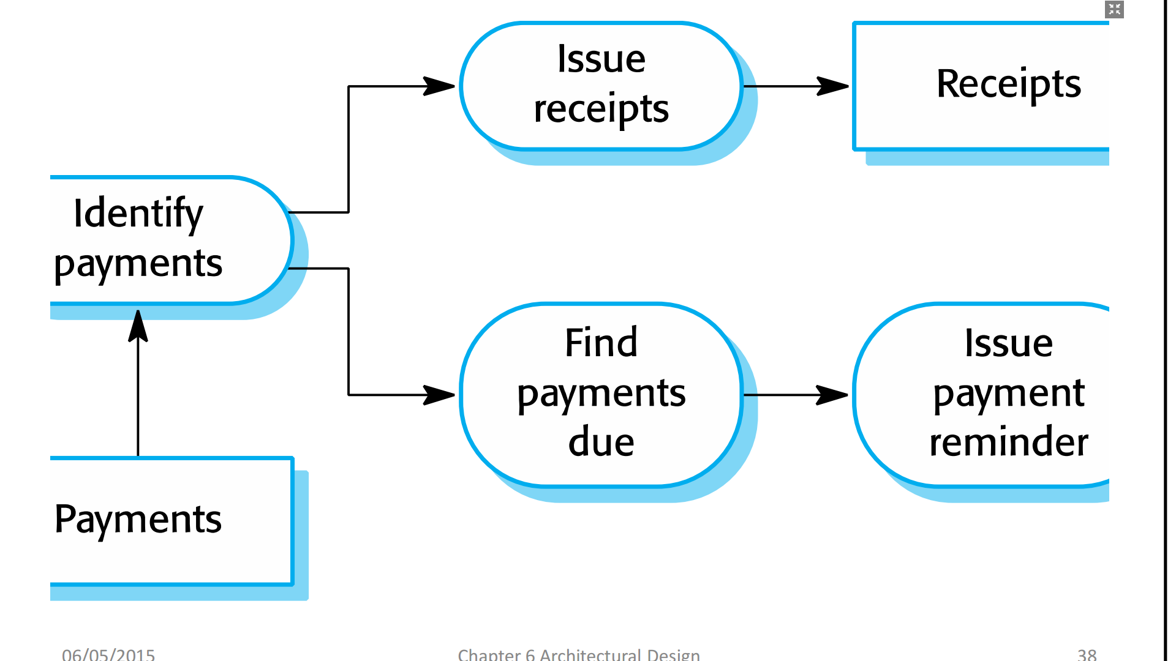
Application architectures
- Application systems are designed to meet an organizational need.
- As businesses have much in common, their application systems also tend to have a common architecture that reflects the application requirements.
- A generic application architecture is an architecture for a type of software system that may be configured and adapted to create a system that meets specific requirements.
Use of application architectures
- As a starting point for architectural design.
- As a design checklist.
- As a way of organizing the work of the development team.
- As a means of assessing components for reuse.
- As a vocabulary for talking about application types.
Examples of application types
Data processing applications: Data driven applications that process data in batches without
explicit user intervention during the processing.
Transaction processing applications: Data-centered applications that process user requests and update
information in a system database.
Event processing systems: Applications where system actions depend on interpreting
events from the system’s environment.
Language processing systems: Applications where the users’ intentions are specified in a formal
language that is processed and interpreted by the system.
Application type examples
- Two very widely used generic application architectures are transaction processing systems and language processing systems.
- Transaction processing systems
+ E-commerce systems;
+ Reservation systems.
- Language processing systems
+ Compilers;
+ Command interpreters.
Transaction processing systems
- Process user requests for information from a database or requests to update the database.
- From a user perspective a transaction is:
+ Any coherent sequence of operations that satisfies a goal;
+ For example - find the times of flights from London to Paris.
- Users make asynchronous requests for service which are then processed by a transaction manager.
The structure of transaction processing applications
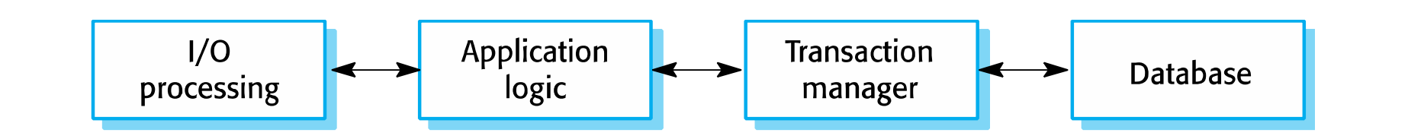
The software architecture of an ATM system

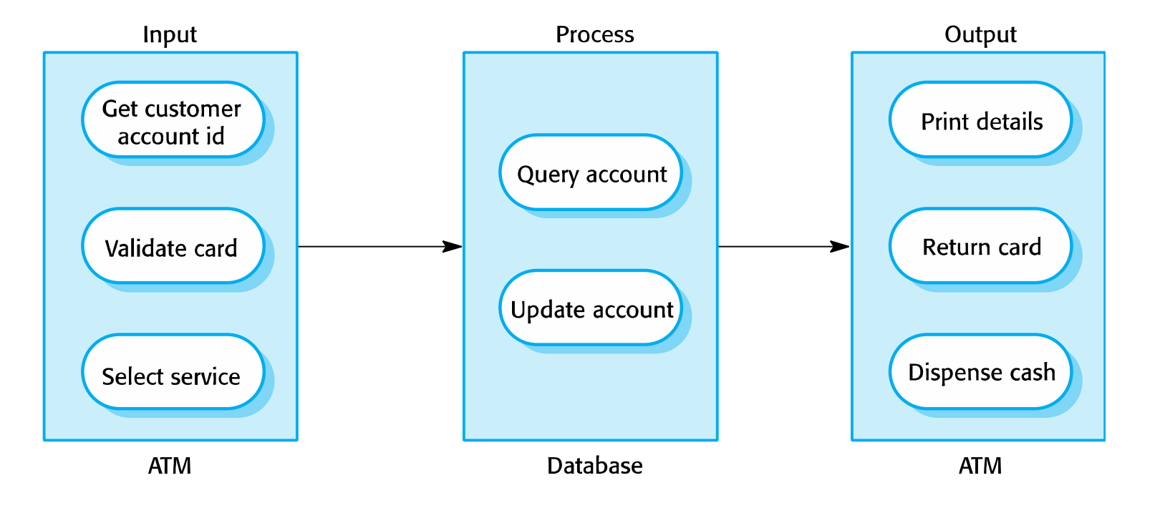
Information systems architecture
- Information systems have a generic architecture that can be organized as a layered architecture.
- These are transaction-based systems as interaction with these systems generally involves database transactions.
- Layers include: The user interface, User communications, Information retrieval, System database

Web-based information systems
- Information and resource management systems are now usually web-based systems where the user interfaces are implemented using a web browser.
- For example, e-commerce systems are Internet-based resource management systems that accept electronic orders for goods or services and then arrange delivery of these goods or services to the customer.
- In an e-commerce system, the application-specific layer includes additional functionality supporting a ‘shopping cart’ in which users can place several items in separate transactions, then pay for them all together in a single transaction.
Server implementation
- These systems are often implemented as multi-tier client server/architectures
+ The web server is responsible for all user communications, with the user interface implemented using a web browser;
+ The application server is responsible for implementing application-specific logic as well as information storage and retrieval requests;
+ The database server moves information to and from the database and handles transaction management.
Language processing systems
- Accept a natural or artificial language as input and generate some other representation of that language.
- May include an interpreter to act on the instructions in the language that is being processed.
-Used in situations where the easiest way to solve a problem is to describe an algorithm or describe the system data
- Meta-case tools process tool descriptions, method rules, etc. and generate tools.
The architecture of a language processing system

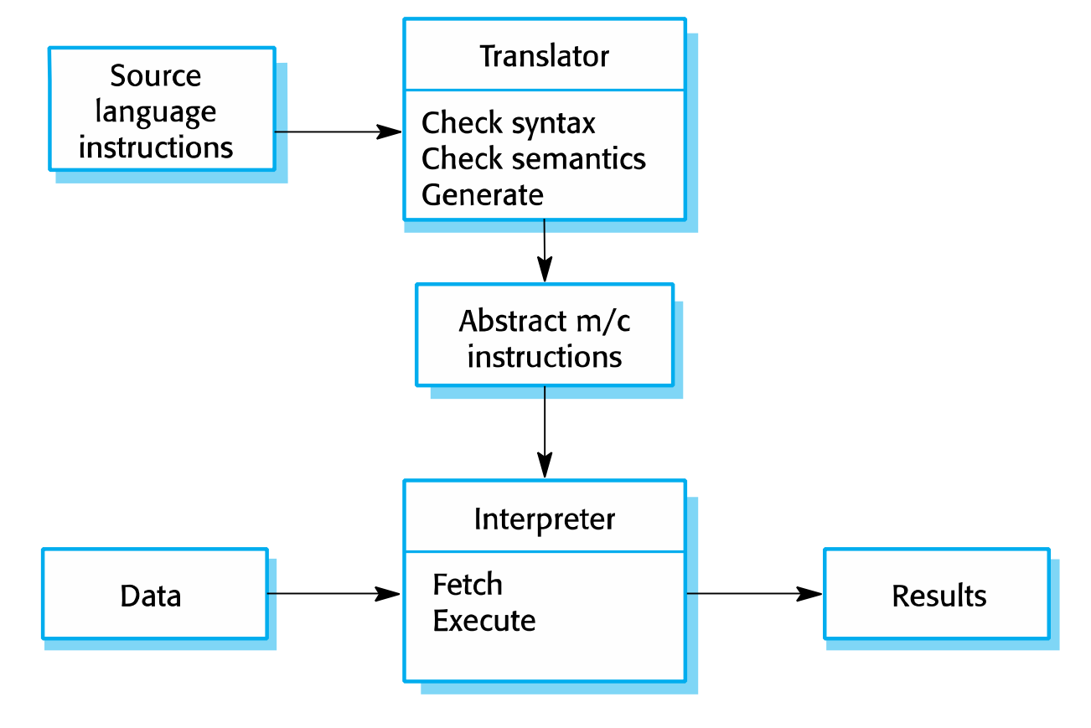
Compiler components
- A lexical analyzer, which takes input language tokens and converts them to an internal form.
- A symbol table, which holds information about the names of entities (variables, class names, object names, etc.) used in the text that is being translated.
- A syntax analyzer, which checks the syntax of the language being translated.
- A syntax tree, which is an internal structure representing the program being compiled.
- A semantic analyzer that uses information from the syntax tree and the symbol table to check the semantic correctness of the input language text.
- A code generator that ‘walks’ the syntax tree and generates abstract machine code.
A repository architecture for a language processing system

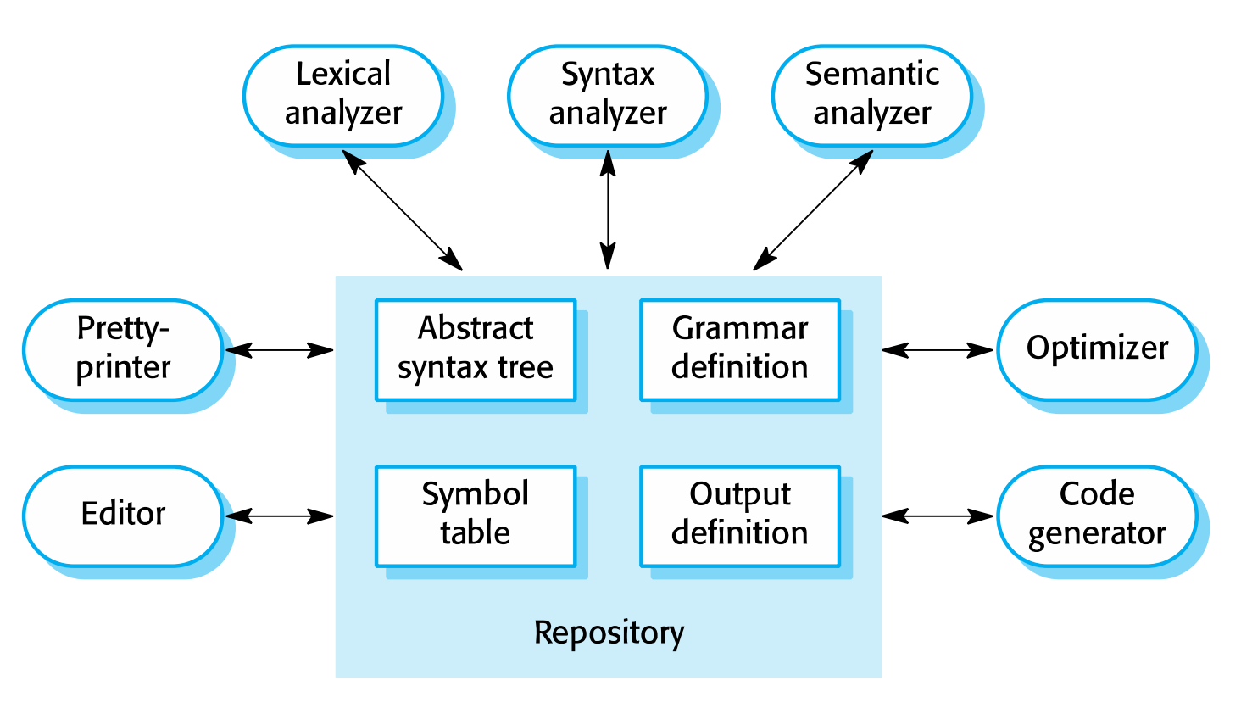
A pipe and filter compiler architecture

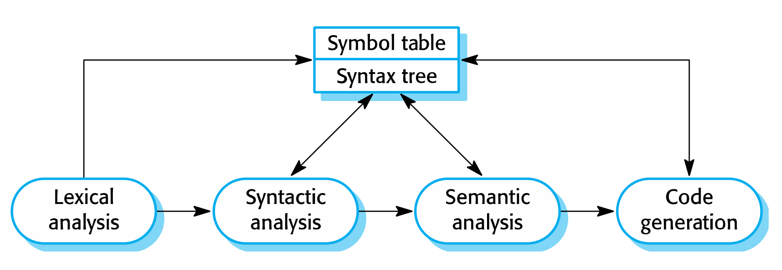
Key points
- A software architecture is a description of how a software system is organized.
- Architectural design decisions include decisions on the type of application, the distribution of the system, the architectural styles to be used.
- Architectures may be documented from several different perspectives or views such as a conceptual view, a logical view, a process view, and a development view.
- Architectural patterns are a means of reusing knowledge about generic system architectures. They describe the architecture, explain when it may be used and describe
its advantages and disadvantages.
- Models of application systems architectures help us understand and compare applications, validate application system designs and assess large-scale components for reuse.
Transaction processing systems are interactive systems that allow information in a database to be remotely accessed and modified by a number of users.
- Language processing systems are used to translate texts from one language into another and to carry out the instructions specified in the input language. They include a translator and an abstract machine that executes the generated language
Quiz
What are the advantage of explicitly designing and documenting a software architecture?
It improves stakeholder communications, It encourages a detailed analysis of the system,
It helps with large-scale reuse.
What are the two ways in which an architectural model of a system may be used?
As a means of facilitating discussion about the most appropriate architecture
for a system. As a means of documenting the architecture of an existing or an intended
system
List 4 fundamental questions that should be addressed in architectural design?.
Is there a generic application architecture that can be used?
How will the system be distributed?
What architectural style or styles are appropriate?
How should the system be structured?
What control strategy should be used?
What are the fundamental architectural views proposed in Crutches 4+1 model?
A logical view that shows the key abstractions of the system.
A process view that shows the interacting processes in the system
A development view that shows how the system is decomposed for development
A physical view that shows the distribution of software on the system hardware
What is an architectural pattern?
A stylized abstract description of good practice in architectural design that has been tried and tested in different systems and environments. The pattern should include information on when it is and is not appropriate to use that architectural design.
What is the fundamental characteristic of a repository architecture?
All shared data is held in a central database that can be accessed by all sub-systems.
What is the most important advantage of a client-server architecture?
This is a distributed architecture so that it is possible to provide services on different computers. It is easy to add a new server or upgrade existing servers without disrupting the system
Briefly describe pipe and filter architecture?
A system is decomposed into a set of functional transformations that consume inputs and produce outputs. Data flows from one function to another (the pipeline) and is transformed as it passes through the sequence.
What is transaction-processing applications?
Database-centered applications that process user requests for information and update the information in the database. They are organized so that transactions cannot interfere with each other and the integrity of the database is maintained.
What are the principal functions of the 4 layers in a generic information system architecture?
User interface
User communications, authentication and authorization
Information retrieval and modification
Database and transaction management

CHAP 7: IMPLEMENTATION
Software design and implementation is the stage in the software engineering process at which an executable software system is developed.
* Software design and implementation activities are invariably inter-leaved.
* Software design is a creative activity in which you identify software components and their relationships, based on a customer’s requirements.
* Implementation is the process of realizing the design as a program.
An object-oriented design process
 Structured object-oriented design processes involve developing a number of different system models.
 They require a lot of effort for development and maintenance of these models and, for small systems, this may not be cost-effective.
 However, for large systems developed by different groups design models are an important communication mechanism.
Process stages
* There are a variety of different object-oriented design processes that depend on the organization using the process.
* Common activities in these processes include:
1. Define the context and modes of use of the system;
2. Design the system architecture;
3. Identify the principal system objects;
4. Develop design models;
5. Specify object interfaces.
* Process illustrated here using a design for a wilderness weather station. *
* Understanding the relationships between the software that is being designed and its external environment is essential for deciding how to provide the required system functionality and how to structure the system to communicate with its environment.
* Understanding of the context also lets you establish the boundaries of the system. Setting the system boundaries helps you decide what features are implemented in the system being designed and what features are in other associated systems.
* A system context model is a structural model that demonstrates the other systems in the environment of the system being developed.
* An interaction model is a dynamic model that shows how the system interacts with its environment as it is used.
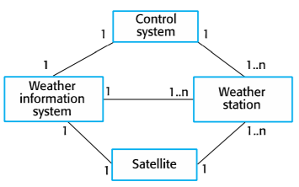System context
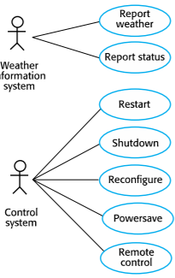Use cases
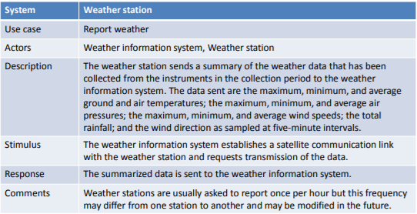Use case description
Architectural design
* Once interactions between the system and its environment have been understood, you use this information for designing the system architecture.
* You identify the major components that make up the system and their interactions, and then may organize the components using an architectural pattern such as a layered or client-server model.
* The weather station is composed of independent subsystems that communicate by broadcasting messages on a common infrastructure.
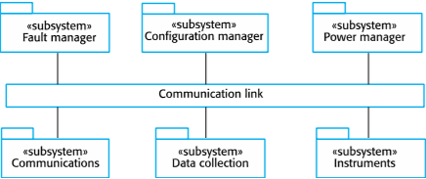High-level architecture
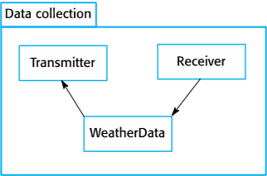Architecture of data collection system
Approaches to identification
 Use a grammatical approach based on a natural language description of the system.
 Base the identification on tangible things in the application domain.
 Use a behavioral approach and identify objects based on what participates in what behavior.
 Use a scenario-based analysis. The objects, attributes and methods in each scenario are identified.
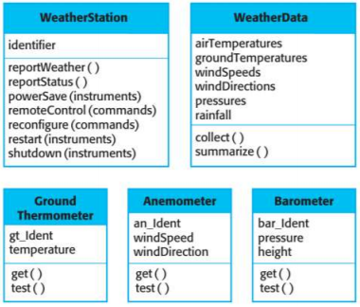Object classes
Design models show the objects and object classes and relationships between these entities.
 There are two kinds of design model:
1 Structural models describe the static structure of the system in terms of object classes and relationships.
2 Dynamic models describe the dynamic interactions between objects.
 Subsystem models that show logical groupings of objects into coherent subsystems.
- Shows how the design is organized into logically related groups of objects.
- In the UML, these are shown using packages – an encapsulation construct. This is a logical model. The actual organization of objects in the system may be different.
 Sequence models that show the sequence of object interactions.
- Objects are arranged horizontally across the top;
- Time is represented vertically so models are read top to bottom;
- Interactions are represented by labelled arrows, different styles of arrow = different types of interaction;
- A thin rectangle in an object lifeline represents the time when the
object is the controlling object in the system.
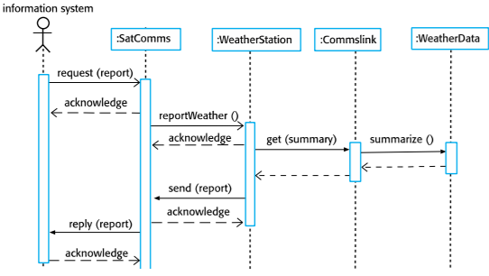
 State machine models that show how individual objects change their state in response to events.
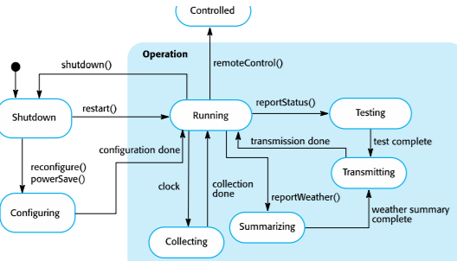
 Other models include use-case models, aggregation models, generalization models, etc.
Kinds of design patterns
1. Structural: relationships between entities
- E.g.: Façade, Decorator, Proxy, Data Access Object, Transfer
Object
2. Creational: instantiation mechanisms
- E.g.: Factory Method, Abstract Factory, Objectpool, Singleton
3. Behavioral: communications between entities
- E.g.: Iterator, Observer, Event Listener, Strategy
Pattern elements: Name, Problem description, Solution description, Consequences
Development platform tools
 An integrated compiler and syntax-directed editing system that allows you to create, edit and compile code.
 A language debugging system.
 Graphical editing tools, such as tools to edit UML models.
 Testing tools, such as Junit that can automatically run a set of tests on a new version of a program.
 Project support tools that help you organize the code for different development projects.
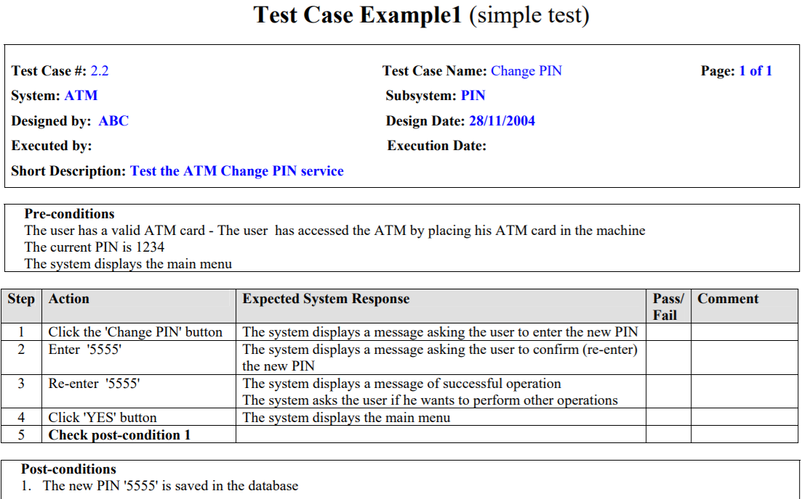

Chapter 8: Testing
Program testing goals:
To demonstrate to the developer and the customer that the software meets its requirements.
To discover situations in which the behaviour of the software is incorrect, undesirable or does not conform to its specification.
Testing process goals:
Validation testing:
1.To demonstrate to the developer and the system customer that the software meets its requirements.
2.A successful test shows that the system operates as intended.
Defect testing:
1.To discover faults or defects in the software where its behaviour is incorrect or not in conformance with its specification.
2.A successful test is a test that makes the system perform incorrectly and so exposes a defect in the system.
Verification vs validation:
Verification:
"Are we building the product right”.
The software should conform to its specification.
Validation:
"Are we building the right product”.
The software should do what the user really requires.
V & V confidence:
Aim of V & V is to establish confidence that the system is ‘fit for purpose’.
Depends on system’s purpose, user expectations and marketing environment:
Software purpose:
The level of confidence depends on how critical the software is to an organisation.
User expectations:
Users may have low expectations of certain kinds of software.
Marketing environment:
Getting a product to market early may be more important than finding defects in the program.
Inspections and testing:
Software inspections Concerned with analysis of the static system representation to discover problems (static verification):
. May be supplement by tool-based document and code analysis.
Software testing Concerned with exercising and observing product behaviour (dynamic verification):
. The system is executed with test data and its operational behaviour is observed.
Software inspections:
. These involve people examining the source representation with the aim of discovering anomalies and defects.
. Inspections not require execution of a system so may be used before implementation.
. They may be applied to any representation of the system (requirements, design, configuration data, test data, etc.).
. They have been shown to be an effective technique for discovering program errors.
Advantage of inspection:
. During testing, errors can mask (hide) other errors. Because inspection is a static process, you don’t have to be concerned with interactions between errors.
. Incomplete versions of a system can be inspected without additional costs. If a program is incomplete, then you need to develop specialized test harnesses to test the parts that are available.
. As well as searching for program defects, an inspection can also consider broader quality attributes of a program, such as compliance with standards, portability and maintainability.
Inspections and testing:
. Inspections and testing are complementary and not opposing verification techniques.
. Both should be used during the V & V process.
. Inspections can check conformance with a specification but not conformance with the customer’s real requirements.
. Inspections cannot check non-functional characteristics such as performance, usability, etc.
Stages of testing:
. Development testing, where the system is tested during development to discover bugs and defects.
. Release testing, where a separate testing team test a complete version of the system before it is released to users.
. User testing, where users or potential users of a system test the system in their own environment.
Development testing:
Development testing includes all testing activities that are carried out by the team developing the system:
. Unit testing, where individual program units or object classes are tested. Unit testing should focus on testing the functionality of objects or methods.
. Component testing, where several individual units are integrated to create composite components. Component testing should focus on testing component interfaces.
. System testing, where some or all of the components in a system are integrated and the system is tested as a whole. System testing should focus on testing component interactions.
Unit testing:
. Unit testing is the process of testing individual components in isolation.
. It is a defect testing process.
. Units may be:
♣ Individual functions or methods within an object.
♣ Object classes with several attributes and methods.
♣ Composite components with defined interfaces used to access their functionality.
Object class testing:
. Complete test coverage of a class involves:
♣ Testing all operations associated with an object
♣ Setting and interrogating all object attributes
♣ Exercising the object in all possible states.
. Inheritance makes it more difficult to design object class tests as the information to be tested is not localised.
Automated testing:
. Whenever possible, unit testing should be automated so that tests are run and checked without manual intervention.
. In automated unit testing, you make use of a test automation framework (such as JUnit) to write and run your program tests.
. Unit testing frameworks provide generic test classes that you extend to create specific test cases. They can then run all the tests that you have implemented and report, often through some GUI, on the success of otherwise of the tests.
Automated test components:
. A setup part, where you initialize the system with the test case, namely the inputs and expected outputs.
. A call part, where you call the object or method to be tested.
. An assertion part where you compare the result of the call with the expected result. If the assertion evaluates to true, the test has been successful if false, then it has failed.
Choosing unit test cases:
- The test cases should show that, when used as expected, the component that you are testing does what it is supposed to do.
- If there are defects in the component, these should be revealed by test cases.
- This leads to 2 types of unit test case:
. The first of these should reflect normal operation of a program and should show that the component works as expected.
. The other kind of test case should be based on testing experience of where common problems arise. It should use abnormal inputs to check that these are properly processed and do not crash the component.
Testing strategies:
- Partition testing, where you identify groups of inputs that have common characteristics and should be processed in the same way:
. You should choose tests from within each of these groups.
- Guideline-based testing, where you use testing guidelines to choose test cases:
. These guidelines reflect previous experience of the kinds of errors that programmers often make when developing components.
Partition testing:
- Input data and output results often fall into different classes where all members of a class are related.
- Each of these classes is an equivalence partition or domain where the program behaves in an equivalent way for each class member.
- Test cases should be chosen from each partition.
General testing guidelines:
- Choose inputs that force the system to generate all error messages.
- Design inputs that cause input buffers to overflow.
- Repeat the same input or series of inputs numerous times.
- Force invalid outputs to be generated.
- Force computation results to be too large or too small.
Component testing:
- Software components are often composite components that are made up of several interacting objects.
. For example, in the weather station system, the reconfiguration component includes objects that deal with each aspect of the reconfiguration.
- You access the functionality of these objects through the defined component interface.
- Testing composite components should therefore focus on showing that the component interface behaves according to its specification.
. You can assume that unit tests on the individual objects within the component have been completed.
Interface testing:
- Objectives are to detect faults due to interface errors or invalid assumptions about interfaces.
- Interface types:
. Parameter interfaces Data passed from one method or procedure to another.
. Shared memory interfaces Block of memory is shared between procedures or functions.
. Procedural interfaces Sub-system encapsulates a set of procedures to be called by other sub-systems.
. Message passing interfaces Sub-systems request services from other sub-systems.
Interface errors:
- Interface misuse:
. A calling component calls another component and makes an error in its use of its interface e.g. parameters in the wrong order.
- Interface misunderstanding:
. A calling component embeds assumptions about the behaviour of the called component which are incorrect.
- Timing errors:
. The called and the calling component operate at different speeds and out-of-date information is accessed.
Interface testing guidelines:
- Design tests so that parameters to a called procedure are at the extreme ends of their ranges.
- Always test pointer parameters with null pointers.
- Design tests which cause the component to fail.
- Use stress testing in message passing systems.
- In shared memory systems, vary the order in which components are activated.
System testing:
- System testing during development involves integrating components to create a version of the system and then testing the integrated system.
- The focus in system testing is testing the interaction between components.
- System testing checks that components are compatible, interact correctly and transfer the right data at the right time across their interfaces.
- System testing tests the emergent behaviour of a system.
System and component testing:
- During system testing, reusable components that have been separately developed and off-the-shelf systems may be integrated with newly developed components. The complete system is then tested.
- Components developed by different team members or sub-teams may be integrated at this stage. System testing is a collective rather than an individual process.
. In some companies, system testing may involve a separate testing team with no involvement from designers and programmers.
Use-case testing:
- The use-cases developed to identify system interactions can be used as a basis for system testing.
- Each use case usually involves several system components so testing the use case forces these interactions to occur.
- The sequence diagrams associated with the use case documents the components and interactions that are being tested.
Test cases derived from sequence diagram:
- An input of a request for a report should have an associated acknowledgement. A report should ultimately be returned from the request.
. You should create summarized data that can be used to check that the report is correctly organized.
- An input request for a report to WeatherStation results in a summarized report being generated.
. Can be tested by creating raw data corresponding to the summary that you have prepared for the test of SatComms and checking that the WeatherStation object correctly produces this summary.
Testing policies:
- Exhaustive system testing is impossible so testing policies which define the required system test coverage may be developed.
- Examples of testing policies:
. All system functions that are accessed through menus should be tested.
. Combinations of functions (e.g. text formatting) that are accessed through the same menu must be tested.
. Where user input is provided, all functions must be tested with both correct and incorrect input.
Test-driven development:
- Test-driven development (TDD) is an approach to program development in which you inter-leave testing and code development.
- Tests are written before code and ‘passing’ the tests is the critical driver of development.
- You develop code incrementally, along with a test for that increment. You don’t move on to the next increment until the code that you have developed passes its test.
- TDD was introduced as part of agile methods such as Extreme Programming. However, it can also be used in plan-driven development processes.
TDD process activities:
- Start by identifying the increment of functionality that is required. This should normally be small and implementable in a few lines of code.
- Write a test for this functionality and implement this as an automated test.
- Run the test, along with all other tests that have been implemented. Initially, you have not implemented the functionality so the new test will fail.
- Implement the functionality and re-run the test.
- Once all tests run successfully, you move on to implementing the next chunk of functionality.
Benefits of test-driven development:
- Code coverage:
. Every code segment that you write has at least one associated test so all code written has at least one test.
- Regression testing:
. A regression test suite is developed incrementally as a program is developed.
- Simplified debugging:
. When a test fails, it should be obvious where the problem lies. The newly written code needs to be checked and modified.
- System documentation:
. The tests themselves are a form of documentation that describe what the code should be doing.
Regression testing:
- Regression testing is testing the system to check that changes have not ‘broken’ previously working code.
- In a manual testing process, regression testing is expensive but, with automated testing, it is simple and straightforward. All tests are rerun every time a change is made to the program.
- Tests must run ‘successfully’ before the change is committed.
Release testing:
- Release testing is the process of testing a particular release of a system that is intended for use outside of the development team.
- The primary goal of the release testing process is to convince the supplier of the system that it is good enough for use.
. Release testing, therefore, has to show that the system delivers its specified functionality, performance and dependability, and that it does not fail during normal use.
- Release testing is usually a black-box testing process where tests are only derived from the system specification.
Release testing and system testing:
- Release testing is a form of system testing.
- Important differences:
. A separate team that has not been involved in the system development, should be responsible for release testing.
. System testing by the development team should focus on discovering bugs in the system (defect testing). The objective of release testing is to check that the system meets its requirements and is good enough for external use (validation testing).
Requirements based testing:
- Requirements-based testing involves examining each
requirement and developing a test or tests for it.
- Mentcare system requirements:
. If a patient is known to be allergic to any particular medication, then prescription of that medication shall result in a warning message being issued to the system user.
. If a prescriber chooses to ignore an allergy warning, they shall provide a reason why this has been ignored.
Requirements tests:
- Set up a patient record with no known allergies. Prescribe medication for allergies that are known to exist. Check that a warning message is not issued by the system.
- Set up a patient record with a known allergy. Prescribe the medication to that the patient is allergic to, and check that the warning is issued by the system.
- Set up a patient record in which allergies to two or more drugs are recorded. Prescribe both of these drugs separately and check that the correct warning for each drug is issued.
- Prescribe two drugs that the patient is allergic to. Check that two warnings are correctly issued.
- Prescribe a drug that issues a warning and overrule that warning. Check that the system requires the user to provide information explaining why the warning was overruled.
Performance testing:
- Part of release testing may involve testing the emergent properties of a system, such as performance and reliability.
- Tests should reflect the profile of use of the system.
- Performance tests usually involve planning a series of tests where the load is steadily increased until the system performance becomes unacceptable.
- Stress testing is a form of performance testing where the system is deliberately overloaded to test its failure behaviour.
User testing:
- User or customer testing is a stage in the testing process in which users or customers provide input and advice on system testing.
- User testing is essential, even when comprehensive system and release testing have been carried out.
. The reason for this is that influences from the user’s working environment have a major effect on the reliability, performance, usability and robustness of a system. These cannot be replicated in a testing environment.
Types of user testing:
- Alpha testing:
. Users of the software work with the development team to test the software at the developer’s site.
- Beta testing:
. A release of the software is made available to users to allow them to experiment and to raise problems that they discover with the system developers.
- Acceptance testing:
. Customers test a system to decide whether or not it is ready to be accepted from the system developers and deployed in the customer environment. Primarily for custom systems.
Stages in the acceptance testing process:
- Define acceptance criteria
- Plan acceptance testing
- Derive acceptance tests
- Run acceptance tests
- Negotiate test results
- Reject/accept system
Agile methods and acceptance testing:
- In agile methods, the user/customer is part of the development team and is responsible for making decisions on the acceptability of the system.
- Tests are defined by the user/customer and are integrated with other tests in that they are run automatically when changes are made.
- There is no separate acceptance testing process.
- Main problem here is whether or not the embedded user is ‘typical’ and can represent the interests of all system stakeholders.
Key points:
- Testing can only show the presence of errors in a program. It cannot demonstrate that there are no remaining faults.
- Development testing is the responsibility of the software development team. A separate team should be responsible for testing a system before it is released to customers.
- Development testing includes unit testing, in which you test individual objects and methods component testing in which you test related groups of objects and system testing, in which you test partial or complete systems.
- When testing software, you should try to ‘break’ the software by using experience and guidelines to choose types of test case that have been effective in discovering defects in other systems.
- Wherever possible, you should write automated tests. The tests are embedded in a program that can be run every time a change is made to a system.
- Test-first development is an approach to development where tests are written before the code to be tested.
- Scenario testing involves inventing a typical usage scenario and using this to derive test cases.
- Acceptance testing is a user testing process where the aim is to decide if the software is good.
QUIZ
Question 1: Write test ideas for this Scenario: You are at Grocery store’s checkout counter. You have bought five items (x, y, z, a, and b). You make payment and move to EXIT door.
Example Test ideas as a hint:
1. If the checkout counter is human less, scan all the five items, scan your card and make payment.
2. The scanners should scan proper relevant information. List all possible test scenarios in comments below.
Answers: Test ideas/scenarios:
1. If the checkout counter is human less, scan all the five items, scan your card and make payment.
2. The scanners should scan proper relevant information.
3. If the checkout counter is human processed, a person to help should be available.
4. All the items bought should have barcode so that they are scan able.
5. All the items should have MRP printed and scan able so that the software can read it
6. The relevant software and printers should be in working condition
7. Once all items scanned, a bill should be generated and given to the customer.
8. For payment multiple options should be allowed, cash, card (credit card, debit card), coupons (meal passes) etc.
9. If payment is done by card, the transactions should be secured.
10. If payment is done by cash, counter person must have enough cash to balance the bill.
11. If any of the item bought is not scannable, the counter person should be able to help customer.
12. Customer should be able to see the EXIT sign easily
13. At EXIT, there should be some check that customer carries only the bought and billed items.

Question 2: As a software tester, what do you do? Of course, testing the software, you
would say………Okay, can you find out defects on the page shown below?

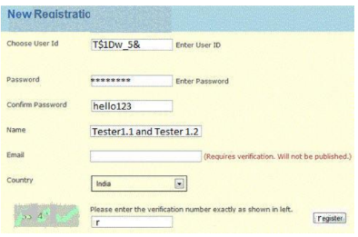
Answers:
1. The user Id field accepts special characters.
2. Confirm password field does not show content in encrypted mode.
3. The name field does not seem to have any validation for number of characters.
4. Captcha is not at all readable.
5. There is no way user can reload the captcha.
6. Register button should be at bottom rather than on side.
7. Register button’s label has “r” instead of “R”.
8. There is no cancel button available if user wants to cancel the procedure.
9. There is no close button available if user wants to close the page.
10. The page title show wrong spelling of Registration.
11. Password selection guideline should be provided like the password should be alpha numeric or password strength factor should be present.
12. Page title should be New User Registration rather than New Registration.
13. Field length and labels should be same for the whole page / form.
14. The country field should by default show “Select” rather than selecting a value default.

CHAP 9 – SOFTWARE EVOLUTION
1. Software change:
- Software change is inevitable:
+ New requirements emerge when the software is used.
+ New requirements emerge when the software is used;
+ Errors must be repaired;
+ New computers and equipment is added to the system;
+ The performance or reliability of the system may have to be improved
- A key problem for all organizations is implementing and managing change to their existing software systems.
2. Importance of evolution:
- Organisations have huge investments in their software systems - they are critical business assets.
- To maintain the value of these assets to the business, they must be changed and updated.
- The majority of the software budget in large companies is devoted to changing and evolving existing software rather than developing new software
3. Evolution and servicing
- Evolution: The stage in a software system’s life cycle where it is in operational use and is evolving as new requirements are proposed and implemented in the system.
- Servicing: At this stage, the software remains useful but the only changes made are those required to keep it operational i.e. bug fixes and changes to reflect changes in the software’s environment. No new functionality is added.
- Phase-out: The software may still be used but no further changes are made to it
4. Evolution process
- Software evolution processes depend on
+ The type of software being maintained;
+ The development processes used;
+ The skills and experience of the people involved.
- Proposals for change are the driver for system evolution: Should be linked with components that are affected by the change, thus allowing the cost and impact of the change to be estimated.
-Change identification and evolution continues throughout the system lifetime.
5. Change implementation
- Iteration of the development process where the revisions to the system are designed, implemented and tested.
- A critical difference is that the first stage of change implementation may involve program understanding, especially if the original system developers are not responsible for the change implementation.
- During the program understanding phase, you have to understand how the program is structured, how it delivers functionality and how the proposed change might affect the program
6. Urgent change requests
- Urgent changes may have to be implemented without going through all stages of the software engineering process
+ If a serious system fault has to be repaired to allow normal operation to continue;
+ If changes to the system’s environment (e.g. an OS upgrade) have unexpected effects;
+ If there are business changes that require a very rapid response (e.g. the release of a competing product)
7. Agile methods and evolution
- Agile methods are based on incremental development so the transition from development to evolution is a seamless one: Evolution is simply a continuation of the development process based on frequent system releases.
- Automated regression testing is particularly valuable when changes are made to a system.
- Changes may be expressed as additional user stories
8. Hangover problems
- Where the development team have used an agile approach but the evolution team is unfamiliar with agile methods and prefer a plan-based approach: The evolution team may expect detailed documentation to support evolution and this is not produced in agile pocesses.
- Where a plan-based approach has been used for development but the evolution team prefer to use agile methods: The evolution team may have to start from scratch developing automated tests and the code in the system may not have been refactored and simplified as is expected in agile development
9. Legacy systems
- Legacy systems are older systems that rely on languages and technology that are no longer used for new systems development.
- Legacy software may be dependent on older hardware, such as mainframe computers and may have associated legacy processes and procedures.
- Legacy systems are not just software systems but are broader socio-technical systems that include hardware, software, libraries and other supporting software and business processes.
10. Legacy system components
- System hardware Legacy systems may have been written for hardware that is no longer available.
- Support software The legacy system may rely on a range of support software, which may be obsolete or unsupported.
- Application software The application system that provides the business services is usually made up of a number of application programs.
- Application data These are data that are processed by the application system. They may be inconsistent, duplicated or held in different databases
- Business processes These are processes that are used in the business to achieve some business objective.
- Business processes may be designed around a legacy system and constrained by the functionality that it provides.
- Business policies and rules These are definitions of how the business should be carried out and constraints on the business. Use of the legacy application system may be embedded in these policies and rules
11. Legacy system replacement
- Legacy system replacement is risky and expensive so businesses continue to use these systems
- System replacement is risky for a number of reasons
+ Lack of complete system specification
+ Tight integration of system and business processes
+ Undocumented business rules embedded in the legacy system
+ New software development may be late and/or over budget
12. Legacy system change
- Legacy systems are expensive to change for a number of reasons:
+ No consistent programming style
+ Use of obsolete programming languages with few people available with these language skills
+ Inadequate system documentation
+ System structure degradation
+ Program optimizations may make them hard to understand
+ Data errors, duplication and inconsistency
13. Legacy system management
- Organisations that rely on legacy systems must choose a strategy for evolving these systems
+ Scrap the system completely and modify business processes so that it is no longer required;
+ Continue maintaining the system;
+ Transform the system by re-engineering to improve its maintainability;
+ Replace the system with a new system.
- The strategy chosen should depend on the system quality and its business value
14. Legacy system categories
- Low quality, low business value: These systems should be scrapped.
- Low-quality, high-business value: These make an important business contribution but are expensive to maintain. Should be re-engineered or replaced if a suitable system is available.
- High-quality, low-business value: Replace with COTS, scrap completely or maintain.
- High-quality, high business value: Continue in operation using normal system maintenance
15. Business value assessment
- Assessment should take different viewpoints into account
+ System end-users;
+ Business customers;
+ Line managers;
+ IT managers;
+ Senior managers.
- Interview different stakeholders and collate results
16. Issues in business value assessment
- The use of the system: If systems are only used occasionally or by a small number of people, they may have a low business value.
- The business processes that are supported: A system may have a low business value if it forces the use of inefficient business processes.
- System dependability: If a system is not dependable and the problems directly affect business customers, the system has a low business value.
- The system outputs: If the business depends on system outputs, then the system has a high business value
17. System quality assessment
- Business process assessment: How well does the business process support the current goals of the business?
- Environment assessment: How effective is the system’s environment and how expensive is it to maintain?
- Application assessment: What is the quality of the application software system?
18. Business process assessment
- Use a viewpoint-oriented approach and seek answers from system stakeholders
+ Is there a defined process model and is it followed?
+ Do different parts of the organisation use different processes for the same function?
+ How has the process been adapted?
+ What are the relationships with other business processes and are these necessary?
+ Is the process effectively supported by the legacy application software?
- Example - a travel ordering system may have a low business value because of the widespread use of webbased ordering.
19. Factors used in environment assessment (Factor and questions)
- Supplier stability: Is the supplier still in existence? Is the supplier financially stable and likely to continue in existence? If the supplier is no longer in business, does someone else maintain the systems?
- Failure rate: Does the hardware have a high rate of reported failures? Does the support software crash and force system restarts?
- Age: How old is the hardware and software? The older the hardware and support software, the more obsolete it will be. It may still function correctly but there could be significant economic and business benefits to moving to a more modern system.
- Performance: Is the performance of the system adequate? Do performance problems have a significant effect on system users?
- Support requirements: What local support is required by the hardware and software? If there are high costs associated with this support, it may be worth considering system replacement.
- Maintenance costs: What are the costs of hardware maintenance and support software licences? Older hardware may have higher maintenance costs than modern systems. Support software may have high annual licensing costs.
- Interoperability: Are there problems interfacing the system to other systems? Can compilers, for example, be used with current versions of the operating system? Is hardware emulation required?
- Understandability: How difficult is it to understand the source code of the current system? How complex are the control structures that are used? Do variables have meaningful names that reflect their function?
- Documentation What system documentation is available? Is the documentation complete, consistent, and current?
- Data Is there an explicit data model for the system? To what extent is data duplicated across files? Is the data used by the system up to date and consistent?
- Programming language Are modern compilers available for the programming language used to develop the system? Is the programming language still used for new system development?
- Configuration management: Are all versions of all parts of the system managed by a configuration management system? Is there an explicit description of the versions of components that are used in the current system?
- Test data Does test data for the system exist? Is there a record of regression tests carried out when new features have been added to the system?
- Personnel skills Are there people available who have the skills to maintain the application? Are there people available who have experience with the system?
20. System measurement
- You may collect quantitative data to make an assessment of the quality of the application system
+ The number of system change requests; The higher this accumulated value, the lower the quality of the system.
+ The number of different user interfaces used by the system; The more interfaces, the more likely it is that there will be inconsistencies and redundancies in these interfaces.
+ The volume of data used by the system. As the volume of data (number of files, size of database, etc.) processed by the system increases, so too do the inconsistencies and errors in that data.
+ Cleaning up old data is a very expensive and time-consuming process
21. Software maintenance
- Modifying a program after it has been put into use.
- The term is mostly used for changing custom software. Generic software products are said to evolve to create new versions.
- Maintenance does not normally involve major changes to the system’s architecture.
- Changes are implemented by modifying existing components and adding new components to the system.
22. Types of maintenance
- Fault repairs
+ Changing a system to fix bugs/vulnerabilities and correct deficiencies in the way meets its requirements.
- Environmental adaptation
+ Maintenance to adapt software to a different operating environment
+ Changing a system so that it operates in a different environment (computer, OS, etc.) from its initial implementation.
- Functionality addition and modification
+ Modifying the system to satisfy new requirements
23. Maintenance effort distribution
- Fault repair: 24%, Environmental adaption (19%), Functionality addition or modification ( 58%).
24. Maintenance costs
- Usually greater than development costs (2* to 100* depending on the application).
- Affected by both technical and non-technical factors.
- Increases as software is maintained. Maintenance corrupts the software structure so makes further maintenance more difficult.
- Ageing software can have high support costs (e.g. old languages, compilers etc.).
- It is usually more expensive to add new features to a system during maintenance than it is to add the same features during development
+ A new team has to understand the programs being maintained
+ Separating maintenance and development means there is no incentive for the development team to write maintainable software
+ Program maintenance work is unpopular
• Maintenance staff are often inexperienced and have limited domain knowledge.
+ As programs age, their structure degrades and they become harder to change
25. Maintenance prediction
- Maintenance prediction is concerned with assessing which parts of the system may cause problems and have high maintenance costs
+ Change acceptance depends on the maintainability of the components affected by the change;
+ Implementing changes degrades the system and reduces its maintainability;
+ Maintenance costs depend on the number of changes and costs of change depend on maintainability
26. Change prediction
- Predicting the number of changes requires and understanding of the relationships between a system and its environment.
- Tightly coupled systems require changes whenever the environment is changed.
- Factors influencing this relationship are
+ Number and complexity of system interfaces;
+ Number of inherently volatile system requirements;
+ The business processes where the system is used.

27. Complexity metrics
- Predictions of maintainability can be made by assessing the complexity of system components.
- Studies have shown that most maintenance effort is spent on a relatively small number of system components.
- Complexity depends on
+ Complexity of control structures;
+ Complexity of data structures;
+ Object, method (procedure) and module size

28. Process metrics
- Process metrics may be used to assess maintainability
+ Number of requests for corrective maintenance;
+ Average time required for impact analysis;
+ Average time taken to implement a change request;
+ Number of outstanding change requests.
- If any or all of these is increasing, this may indicate a decline in maintainability

29. Software reengineering
- Restructuring or rewriting part or all of a legacy system without changing its functionality.
- Applicable where some but not all sub-systems of a larger system require frequent maintenance.
- Reengineering involves adding effort to make them easier to maintain. The system may be restructured and re-documented

30. Advantages of reengineering
- Reduced risk: There is a high risk in new software development. There may be development problems, staffing problems and specification problems.
- Reduced cost: The cost of re-engineering is often significantly less than the costs of developing new software.

31. Reengineering process activities
- Source code translation: Convert code to a new language.
- Reverse engineering: Analyse the program to understand it;
- Program structure improvement: Restructure automatically for understandability;
- Program modularisation: Reorganise the program structure;
- Data reengineering: Clean-up and restructure system data.

32. Reengineering cost factors
- The quality of the software to be reengineered.
- The tool support available for reengineering.
- The extent of the data conversion which is required.
- The availability of expert staff for reengineering: This can be a problem with old systems based on technology that is no longer widely used

33. Refractoring
- Refactoring is the process of making improvements to a program to slow down degradation through change.
- You can think of refactoring as ‘preventative maintenance’ that reduces the problems of future change.
- Refactoring involves modifying a program to improve its structure, reduce its complexity or make it easier to understand.
- When you refactor a program, you should not add functionality but rather concentrate on program improvement

34. Refactoring and reengineering
- Re-engineering takes place after a system has been maintained for some time and maintenance costs are increasing. You use automated tools to process and reengineer a legacy system to create a new system that is more maintainable.
- Refactoring is a continuous process of improvement throughout the development and evolution process. It is intended to avoid the structure and code degradation that increases the costs and difficulties of maintaining a system.

35. ‘Bad smells’ in program code
- Duplicate code: The same or very similar code may be included at different places in a program. This can be removed and implemented as a single method or function that is called as required.
- Long methods: If a method is too long, it should be redesigned as a number of shorter methods.
- Switch (case) statements: These often involve duplication, where the switch depends on the type of a value. The switch statements may be scattered around a program. In object-oriented languages, you can often use polymorphism to achieve the same thing.
- Data clumping: Data clumps occur when the same group of data items (fields in classes, parameters in methods) re-occur in several places in a program. These can often be replaced with an object that encapsulates all of the data.
- Speculative generality: This occurs when developers include generality in a program in case it is required in the future. This can often simply be removed

36. Key points
- Software development and evolution can be thought of as an integrated, iterative process that can be represented using a spiral model.
- For custom systems, the costs of software maintenance usually exceed the software development costs.
- The process of software evolution is driven by requests for changes and includes change impact analysis, release planning and change implementation.
- Legacy systems are older software systems, developed using obsolete software and hardware technologies, that remain useful for a business.
- It is often cheaper and less risky to maintain a legacy system than to develop a replacement system using modern technology.
- The business value of a legacy system and the quality of the application should be assessed to help decide if a system should be replaced, transformed or maintained.
- There are 3 types of software maintenance, namely bug fixing, modifying software to work in a new environment, and implementing new or changed requirements.
- Software re-engineering is concerned with re-structuring and re-documenting software to make it easier to understand and change.
- Refactoring, making program changes that preserve functionality, is a form of preventative maintenance.
QUIZ
Ex1. Evolution: Identify a function which needs to be improved/changed in your software product, what components/functions will be impacted? What errors will be able to be caused? Make a plan to enhance that software system.
- Sample answers:
o In an online book shopping system, the book viewing function needs to be improved.
o Present problems: this function only shows the title, cover page, and price of a product, but no customer reviews and no free preview
o Impacts: adding the customer reviews will impact the customer relationship management component, and adding the free preview will not impact the other components → adding the free preview will be carried out first.
o Causable errors:
+ Adding the customer reviews causes some business constraint issues, e.g., what books are most interesting? How to calculate average? What books are most interested by a customer?
+ Adding the free preview might not cause severe errors.
o Plan:
+ (1) Adding the free preview: Embedding a PDF document into the website to load 5-10 sample pages for previewing a book.
+ (2) Develop a review module allowing star ratings and comments. To do this, need to redesign the parts in database which related to customers and books, redesign the book viewing interface, implement and validate

Ex2. WorkingWithLegacySystems-sample: students need to assume and assess the existing system to make a plan or a development strategy
Sample answer:
1. Business value assessment
a. The use of the system: the system is used by a small group of people → the system has low business value.
b. The business processes: inefficient → low business value
c. System dependability: the system affects the business customers, if the system does not work → customers cannot get their furniture. → high business value
d. The system outputs: the business still depends on system outputs → high business value
2. System quality assessment
a. Business process assessment (How well does the business process support the current goals of the business?)
It is assumed that the system supports the business tasks, but it needs to be improved and adapt to the current requirements. → high business value
b. Environment assessment (How effective is the system’s environment and how expensive is it to maintain?)
The system has been used for 12 years, so the performance of the system does not satisfy the users’ requirements. → upgrade the system, friendlier interface
c. Application assessment (What is the quality of the application software system?)
If the document of the system exists → maintain and improve
If the document of the system does not exist → re-engineer
For the data, we need to check the ERD and if the data of the system is up to date.
Evaluate the performance of the software process and hardware, we need to upgrade the hardware if necessary and optimize the algorithms
TESTBANK
Chap 5
1. Perspectives used in system modeling ● Behavioral, where you model the dynamic behavior of the system and how it responds to events. ● Interaction, where you model the interactions between a system and its environment or between the components of a system. ● Structural, where you model the organization of a system or the structure of the data that is processed by the system.● External, where you model the context or environment of the system.
2. What are the 5 types of UML diagrams ● Activity diagrams, which show the activities involved in a process or in data processing ● Use case diagrams, which show the interactions between a system and its environment ● Sequence diagrams, which show interactions between actors and the system between system components ● Class diagrams, which show the object classes into the system and the associations between these classes. ● State diagrams, which show how the system reacts to internal and external events.
3. Context Model ● Interactions between a system and external actors
4. Activity diagrams ● Used to express the context of a system. ● Shows the activities that make up a system process ● Flow of control from one activity to the next
5. Use case modeling ● Interactions between a system and external actors
6. Components of a text based Use Case ● Actors ● Description ● Data ● Stimulus ● Response ● Comments
Chap 6
1. What are the advantages of explicitly designing and documenting a software architecture? ● Improved stakeholder communications ● Helps with large scale reuse ● Encourages a detailed analysis of the system
2. What are the two ways in which an architectural model of a system may be used? ● Facilitating discussion about the most appropriate architecture for a system. ● Documenting the architecture of an existing or intended system
3. List 4 fundamental questions that should be addressed in architectural design? ● How should the system be structured? ● What control strategy should be used? ● How will the system be distributed? ● What architectural structure is appropriate?
4. What are the fundamental architectural views proposed in Krutchenʼs 4+ 1 model? ● A logical view ● A process view ● A development view ● A physical view
5. What is an architectural pattern? ● An abstract description of good practice in architectural design that has been tested in many different systems and environments.
6. What is the fundamental characteristic of a repository architecture? ● All shared data is held in a central database that can be accessed by all sub. systems.
7. What is the most important advantage of a client. server architecture? ● It is easy to add a new server or upgrade existing servers without disrupting the system.
8. Briefly describe pipe and filter architecture? ● A system is decomposed into a set of functional transformations that consume inputs and produce outputs. Data flows from one function to another and is transformed as it passes through the sequence.
9. What are transaction. processing applications? ● Database centered applications that process user requests for information and update the information in the database.
10. What are the principal functions of the 4 layers in a generic information system architecture? ● User interface ● User communications, authentication and authorization ● Information retrieval and modification● Database and transaction management
Chap 7
the software tester is unaware of the software's insides, also known as beta testing ● black-box testing
grant of property right to the inventor, lasts 20 years, owner can prevent others from creating or selling the invention ●patent
The development process can switch back and forth between different stages ● free-wheeling model
simplify the software development process ● computer-aided software engineering tools
protects the form of expression rather than the subject matter of the writing ● copyright
prototyping: Similar to incremental model inheritance: Re-using classes with minor adjustments coupling: Measure of software complexity modules: manageable units of a software components: Re-usable units of software Maximizing module independence: inter-module coupling testing each module separately: module testing prevents others from using a similar logo/design/mark: trademark rights
Degree of relatedness of modules internal parts, important to maximize: cohesion
Ex: many physicians per patient and many patients per physician: many-to-many relationship
explains how to install, instructions for updating: technical documentation

CHAP 8
What is the difference between validation and verification?
'Validation: Are we building the right product?'
'Verification: Are we building the product, right?'
The aim of verification is to check that the software meets its stated functional and non- functional requirements. Validation, however, is a more general process. The aim of validation is to ensure that the software meets the customer's expectations.
What are the advantages of inspection over testing? ● During testing, errors can mask (hide) other errors. Because inspection is a static process, you don't have to be concerned with interactions between errors. ● Incomplete versions of a system can be inspected without additional costs. If a program is incomplete, then you need to develop specialized test harnesses to test the parts that are available. ● As well as searching for program defects, an inspection can also consider broader quality attributes of a program, such as compliance with standards, portability and maintainability.
List 3 principle stages of testing for commercial software. ● Development testing, where the system is tested during development to discover bugs and defects. ● Release testing, where a separate testing team tests a complete version of the system before it is released to users. ● User testing, where users or potential users of a system test the system in their own environment.
What tests should be included in object class testing? ● Test all operations associated with the object. ● Set and check the value of all attributes associated with the object. ● Put the object into all possible states.
What guidelines are suggested for defect testing? ● Choose inputs that force the system to generate all error messages. ● Design inputs that cause input buffers to overflow. ● Repeat the same input or series of inputs numerous times. ● Force invalid outputs to be generated. ● Force computation results to be too large or too small.
Equivalence partition, support with example.
● Input data and output results often fall into different classes where all members of a class are related. ● Each of these classes is an equivalence partition or domain where the program behaves in an equivalent way for each class member. ● Test cases should be chosen from each partition.
List 3 important classes of interface errors. ● Interface misuse A calling component calls some other component and makes an error in the use of its interface. ● Interface misunderstanding A calling component misunderstands the specification of the interface of the called component and makes assumptions about its behavior. ● Timing errors These occur in real- time systems that use a shared memory or a message- passing interface.
Principle concerns of system testing.
System testing checks that components are compatible, interact correctly and transfer the right data at the right time across their interfaces.
Scenario testing
Scenario testing is an approach to release testing where you devise typical scenarios of use and use these to develop test cases for the system.
Performance Testing (Stress Testing)
Stress testing is particularly relevant to distributed systems based on a network of processors. These systems often exhibit severe degradation when they are heavily loaded. The network becomes swamped with coordination data that the different processes must exchange. The processes become slower and slower as they wait for the required data from other processes. Stress testing helps you discover when the degradation begins so that you can add checks to the system to reject transactions beyond this point.
User Testing (3 types)
User or customer testing is a stage in the testing process in which users or customers provide input and advice on system testing.
- Alpha testing, where users of the software work with the development team to test the software at the developer's site.
- Beta testing, where a release of the software is made available to users to allow them to experiment and to raise problems that they discover with the system developers.
- Acceptance testing, where customers test a system to decide whether or not it is ready to be accepted from the system developers and deployed in the customer environment.
Release Testing
Release testing is the process of testing a particular release of a system that is intended for use outside of the development team.

TESTBANK CHAP 9
1. software evolution depends on ● type of software, development process, skills of people involved
2. change identification and evolution processes ● change identification -> change proposals -> software evolution process -> new system ->
3. change implementation ● proposed changes <-> requirement analysis ->requirements updating -> software development
4. emergency repair process ● change request -> analyse source code -> deliver modified system
5. program evolution dynamics ● is the study of the processes of system change
6. Lehman's laws ● continuing change, increasing complexity, large program evolution, organizational stability, conservation of familiarity, continuing growth, declining quality, feedback system
7. types of maintenance ● repair software faults, adapt software, modify system's functionality
8. maintenance cost factors ● team stability, contractual responsibility, staff skills, program age and structure
9. maintenance prediction ● concerned with assessing which parts of the system may cause problems and have high maintenance costs
10. change prediction ● predicting the number of changes requires and understanding of the relationships between a system and its environment
11. complexity metrics ● depends on: control structures, data structures, object, method, module sizes
12. process metrics ● depends on: number of requests for correcting mistake, average time for impact analysis, average time taken to implement request, number of outstanding change requests
13. system re-engineering ● re-structuring or re-writing part or all of a legacy system without changing its functionality
14. advantages of system re-engineering ● reduced risk and reduced cost
15. re-engineering processes activities ● source code translation, reverse engineering, program structure improvement, program modularization, data re-engineering
16. re-engineering cost factors ● quality of software to be re-engineered, tool support, extent of data conversation, availability of expert staff
17. refactoring ● continuous processes of improvement throughout the development and evolution process. To avoid the structure and code degradation that increases costs and maintenance difficulties
18. re-engineering over refactoring ●takes place after a system has been maintained for a long time and maintenance cost is increasing. using automated tools to process and re-engineer a legacy system a new system is created thats more maintainable
19. 'bad smells' in a program ● duplicate code, long methods, switch/case statements, data clumping, speculative generality
20. legacy system management strategies ● scrap the system and modify business so its not needed, continue maintenance, re-engineer the system, replace the system
21. legacy system categories
low quality, low value (scrap it); low quality, high value(re-engineer or replace); high quality, low value(scrap or maintain); high quality, high value(continue using)
22. issues in business value assessment
use of the system, business processes that are supported, system dependability, system outputs.
23. system quality assessment
business process assessment, environment assessment, application assessment
24. factors in environmental assessment
supplier stability, failure rate, age, performance, support requirements, maintenance costs, interoperability
25. factors in application assessment
understandability, documentation, data, performance, program language, configuration management, test data, personnel skills

5.Explain why a software system that is used in a real-world environment must change or become progressively less useful.
Ans: Systems must change or become progressively less useful for a number of reasons:
1. The presence of the system changes the ways of working in its environment and this generates new requirements. If these are not satisfied, the usefulness of the system declines.
2. The business in which the system is used changes in response to market forces and this also generates new system requirements.
3. The external legal and political environment for the system changes and generates new requirements. 4. New technologies become available that offer significant benefits and the system must change to take advantage of them
4. You have been asked to test a method called ‘catWhiteSpace’ in a ‘Paragraph’ object that, within the paragraph, replaces sequences of blank characters with a single blank character. Identify testing partitions for this example and derive a set of tests for the ‘catWhiteSpace’ method.
Ans:
Testing partitions are: Strings with only single blank characters Strings with sequences of blank characters in the middle of the string Strings with sequences of blank characters at the beginning/end of string Examples of tests: The quick brown fox jumped over the lazy dog (only single blanks) The quick brown fox jumped over the lazy dog (different numbers of blanks in the sequence) The quick brown fox jumped over the lazy dog (1st blank is a sequence) The quick brown fox jumped over the lazy dog (Last blank is a sequence) The quick brown fox jumped over the lazy dog (2 blanks at beginning). The quick brown fox jumped over the lazy dog (several blanks at beginning) The quick brown fox jumped over the lazy dog (2 blanks at end) The quick brown fox jumped over the lazy dog (several blanks at end)

